Unit 14. Paging Space
What This Unit Is About
This unit outlines the concepts of paging space.
What You Should Be Able To Do
After completing this unit, students should be able to:
- Define why paging space is required in AIX
- List and monitor the pacing space utilization of the system
- Carry out corrective actions to rectify too little or too much pacing space scenarios
How You Will Check Your Progress
Accountability:
- Checkpoint questions
- Exercises
References
- AIX Version 4.l System Management Guide: Operating System and Devices SC23-2525
- AIX Version 3.2 and 4.1 Performance Tuning Guide
SC23-2365

14.1 Objectives
After completing this unit, students should be able to:
- Define why paging space is required in AIX
- List and monitor the pacing space utilization of the system
- Carry out corrective actions to rectify too little or too much pacing space scenarios
Notes:

14.2 What Is Paging Space?
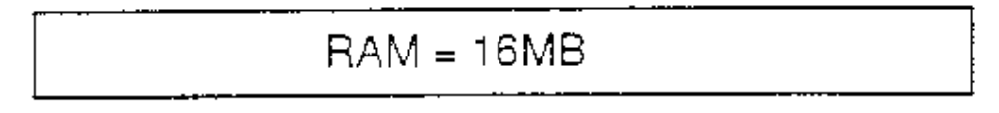Assume this system is running the operating system, TCP/IP and Xwindows.
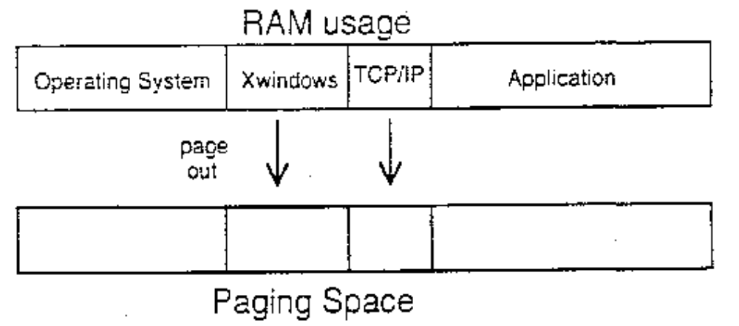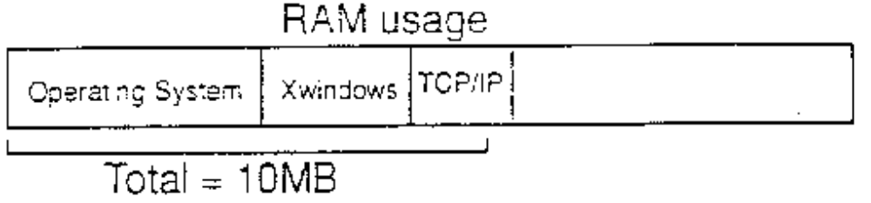If an application that requires 8MB of RAM is started, then something in RAM has to be moved (page out) to make room for the application without losing easy access to the moved information should it be needed again.
Notes:
- Paging space is used to back real memory. Real memory is divided into 4K sections called page frames. Each page frame is backed by 4K pages in paging space on disk . All applications and data to be used by applications get loaded into page frames and then mapped to page space.
- When the system goes to access data and it is not in real memory, the system looks for page frames that have not been recently referenced. When it locates what it needs, if the data in the page frame has been changed, the system will “page out” the data to the page in paging space thus updating the information in page space. If it hasn't been changed, then the page is “stolen”. Under either circumstance, a “page in” from paging space will occur.

14.3 Why Do We Need Paging Space?
- When real memory is over committed the paging space is used as secondary memory
- Only active parts of programs and data need to be resident in real memory
- At system installation paging space is created which is up to twice the size of real memory
However the amount of paging space required is directly dependent on the type
of applications installed
- Paging space should be monitored regularly with the lsps -a command and if usage is constantly > 70%, more paging space should be added
- When paging space runs low, then a message is sent to the console. No new processes can be created and the system may stop
- Not a substitute for real memory
Notes:
- Paging space is disk storage for information that is resident in virtual memory, but is not currently being accessed. When the amount of free real memory in the system is low, programs or data that have not been used recently are moved from real memory to paging space in order to free real memory for other activities.
- Paging space is not a substitute for real memory. Increasing the size of paging space may not benefit real memory intensive applications that are pinned in memory. Too much paging could result in a thrashing condition where the system spends more time in paging than in doing real work.

14.4 Paging Space Placement on Disk
- Paging space is a logical volume with attribute type equal to paging
- To maximize paging performance with a logical volume:
- allocate in the middle of the disk to reduce disk arm travel
- use multiple paging spaces, each allocated on a separate physical volume
- move paging space activity to disks that are less busy
Notes:
- During installation paging space (hd6) is created by default on drive hdisk0 which contains part or all of the busy root and /usr file system. If there are two or more disks which have the operating system installed on them, then the system during installation will split the-paging space requirement over all the disks and will name the areas as hd6n.
- By default, paging space is located in midway partitions and not the center ones.

14.5 Paging Space
- To list all the paging spaces, either go through SMIT or execute the lsps –a command
# lsps –a
Page Space Physical Volume Volume Group Size %Used Active Auto Type
hd6 hdisk0 rootvg 32MB 43% yes yes lv
paging00 hidsk2 myvg 32MB 20% yes yes lv
- To see how much real memory is on the system
# lsdev –Cc memory
- The /etc/swapspaces file lists all the paging spaces that are automatically brought on-line on each system restart.
# pg /etc/swapspaces
hd6:
dev = /dev/hd6
paging00:
dev = /dev/paging00

Notes:
- The lsps command lists details of the paging spaces on the system including whether they are in use at the time and, if so. what percentage of their total space is allocated.
- The file /etc/swapspaces contains details of the paging space volumes that are to be activated at system startup.
- Another useful option available with the lsps command is the –s option which specifies the summary characteristics of all paging spaces. The information consists of the total size of the paging spaces ( in MBs) and the percentage of paging spaces currently used.
- You can also use the command lsattr –EL sys0 –a realmem to list the amount of memory on the system.

14.6 Adding Paging Space
# smit mkps
Add Another Paging Space

Type or select values in entry fields.
Press Enter AFTER making all desired changes.

[Entry Fields]
Volume group name rootvg
SIZE of paging space (in logical partitions) [1] #
PHYSICAL VOLUME name +
Start using this paging space NOW? no +
Use this paging space each time the system is
RESTARTED? no +

F1=Help F2=Refresh F3=Cancel F4=List
F5=Reset F6=Command F7=Edit F8=Image
F9=Shell F10=Exit Enter=Do

Note:
- To add extra paging space volumes to the system, use the mkps command. The options are:
- volumegroup The volume group within which to create the paging space
- physicalvolume The physical volume within that volume group if there is more
than one
- -s size Sets the size of the new paging space in physical partitions
- -a Activate the paging space at the next restart, (add it to
/etc/swapspaces)
- -n Activate the paging space immediately.
- When a paging space is created, then the /etc/swapspaces file is also updated.
- The high level command is :
- # mkps –s 2 –n rootvg

14.7 Change Paging Space
- Change / Show Characteristics of a Paging Space
# smit chps
Change / Show Characteristics of a Paging Space

Type or select values in entry fields.
Press Enter AFTER making all desired changes.

[Entry Fields]
Paging space name paging00
Volume group name rootvg
Physical volume name hdisk2
NUMBER of additional logical partitions [] #
Use this paging space each time the system is
RESTARTED? yes +

F1=Help F2=Refresh F3=Cancel F4=List
F5=Reset F6=Command F7=Edit F8=Image
F9=Shell F10=Exit Enter=Do

- Activate a Paging Space
swapon /dev/pagingnn..
swapon -a
Notes:
- Paging space may have its size increased (not decreased) and may have its autostart options changed while it is in use (this updates /etc/swapspaces). The high level command to perform this action is chps.
- Inactive paging spaces may be activated dynamically once they have been defined. To do this enter: swapon /dev/pagingnn (Note: this operation is supported through SMIT as well, fastpath pgsp). Alternatively, use: swapon –a to activate all paging spaces defined in /etc/swapspaces. This command is run in /etc/rc at system startup. Active paging spaces may not be deactivated while the system is running. This can, however, be marked to be deactivated at the next system boot.

14.8 Remove Paging Space
- Active paging space cannot be removed. In order to remove an active paging space:
- First make it inactive at next boot time
# chps -a ‘n’ paging00
- Reboot the system
- Remove inactive paging space
# rmps paging00
- Note: Beware that the first paging space /dev/hd6 cannot be removed using this process
Notes:
- Paging space can be added to the system, and surplus paging space can be deleted to free up the disk space for other logical volumes. In order to delete paging space it must be inactive, (i.e.. not used by the kernel.) Inactive paging space can be activated dynamically to meet system demand but not deactivated until the next system restart.

14.9 Problems with Paging Space
- Paging space too small:
- Dynamically increase the size by allocating more partitions
- Paging space too large (only for user created paging space):
- Create a paging space of a smaller size (mkps)
- Mark the large paging space not to be activated at next boot (chps)
- Reboot the system (shutdown -Fr)
- Remove the inactive paging space (rmps)
Notes:
The steps outlined on the previous page cannot be used for system defined paging spaces for example, hd6, because these are created dynamically at boot time from the /sbin/rc.boot shell script.

14.10 Documenting Paging Space Setup
- Run the lsps command
- Have a hardcopy of the /etc/swapspaces file
Notes:

14.11 Checkpoint
Exercise - Paging Space
1. What problems can you conclude from the following listing?
Pace Space Physical Volume Volume Group Size %Used Active Auto Type
Paging00 hdisk0 myvg 64MB 7% yes yes lv
paging0l hdisk0 myvg 16MB 89% yes yes lv

2. The size of paging00 (in the above diagram) can be dynamically decreased. True or False.
Why?
How could you work around the problem?

14.12 Unit Summary
- Paging space is a requirement in AIX for the system to boot up, the default one being /dev/hd6
- The percent utilization of all the paging spaces should be regularly monitored to ensure that the system has the correct amount of swapspace defined
- The size of a paging space can be increased on the fly, however, to remove a paging space it must first be deactivated at the next boot and then removed

